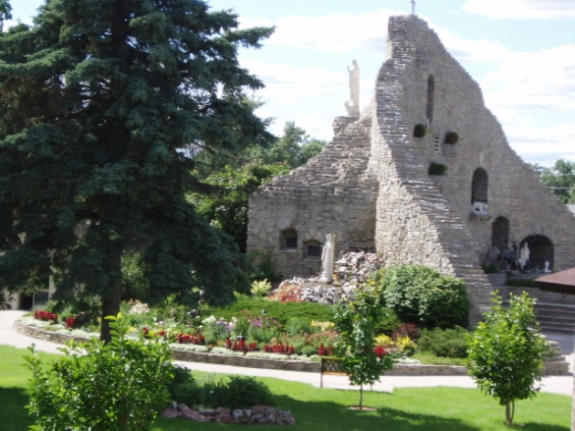
Our Lady of the Woods Shrine
Legacy Pavers

Sixty years of weather has taken a toll on Our Lady of the
Woods Shrine. We have been working to restore it and to help
ensure that it remains a place of beauty and spiritual inspiration
for generations to come.

The Legacy Pavers are one way to help fund this expensive renovation. The pavers are also a way to honor those we love, and memorialize those we’ve lost. You can have your family name engraved or a brief scripture verse.

The engraved pavers will be placed along the length of the sidewalk surrounding the shrine.

Prices for the pavers are:
4” x 8” $ 100 This will accommodate up to 3 lines of text
8” x 8” $ 200 This size will allow up to 6 lines of text for your message.

Please complete this form as you would like your paver to read and mail it to the parish office,
along with your payment.
Please make checks out to: Our Lady of the Woods Shrine Memo line: Legacy Paver
Mailing address: St. Mary Church, PO Box 189, Mio, MI 48647

Everything will be centered. Please fill out the spaces below, as you would like it to read. A letter for each space.
A comma, dash, period or other symbol or punctuation is considered one space and goes in its own box.
4X
8

Your Name ______________________________________________________________________________________
Address _________________________________________________________________________________________
Phone ________________________________ Email _____________________________________________________
8
X
8

